### Current Activities

The 4691 “Moonshine” leisure / pub terminal is now on display in the Hursley room. After 30 years in someone’s garage it was rather dirty, but has cleaned up rather nicely. Unfortunately it is not in working order, probably with power supply problems. The coasters were produced at the same time as the hardware development and show made-up pub signs.

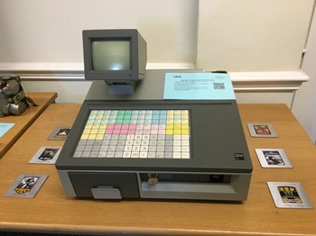 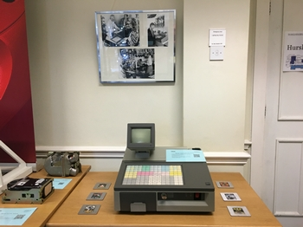

### 360/40 Archive

Now that we have identified at least some of the content of the ‘top safe’, the question is what to do with 300+ boxes. We’ve decided to put the boxes we took out back with the rest, take some more photos, catalogue their existence and leave them in peace.

### Donations

The latest donation is an ITR clocking-in machine with IBM UK serial plate / service phone numbers inside and a short history on the back. The clocking-in mechanism is completely seized, but with that disconnected the clock itself runs well.

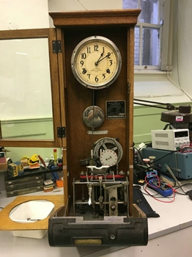 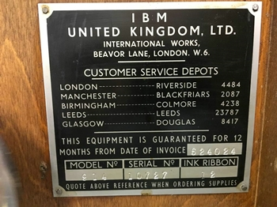 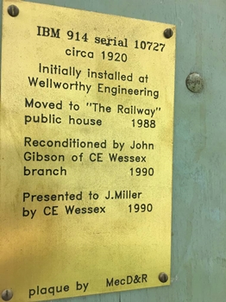

### Hursley 60th

The Museum supported a final celebration event for IBM employees to commemorate the actual anniversary of IBM coming to Hursley in December 1958 by providing a display featuring a number of awards, artefacts and images charting the history of both the site itself and the achievements of its staff.